NATIONAL INSTITUTE OF TECHNOLOGY KARNATAKA SURATHKAL

DEPARTMENT OF INFORMATION TECHNOLOGY

IT 301 Parallel Computing LAB 2

19th August 2020

Faculty: Dr. Geetha V and Mrs. Tanmayee

-------------------------------------------------------------------------------------------------------------------------------

Execute following programs and put screen shots of the output. Write analysis of the result before uploading in IRIS as a single pdf file. for programming exercises, write the code and also put screenshot of the results.

**1. Program 1**

**Aim: To understand and analyze shared clause in parallel directive.**

/*shared.c*/

#include<omp.h>

int main()

{

int x=0;

#pragma omp parallel shared(x)

{

int tid=omp_get_thread_num();

x=x+1;

printf(“Thread [%d]\n value of x is %d”,tid,x);

}

}

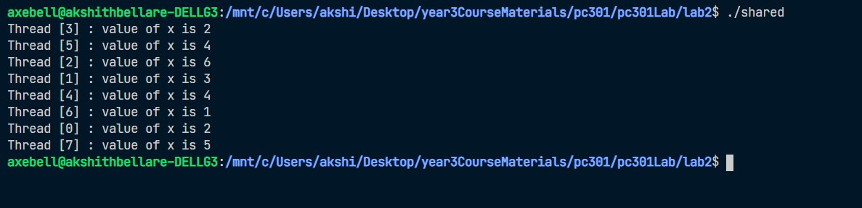

X is shared among all the threads. Two threads might increment X at the same time.

For example in the above screenshot thead 6 sets X to 1 and then thread 3 and thread 0 both increment X to 2 at the same time.

**2. Program 2**

**Learn the concept of private(), firstprivate()**

/*learn.c*/

#include<stdio.h>

#include<omp.h>

int main()

{

int i=10;

printf("Value before pragma i=%d\n",i);

#pragma omp parallel num_threads(4) private(i)

{

printf("Value after entering pragma i=%d tid=%d\n",i, omp_get_thread_num());

i=i+omp_get_thread_num(); //adds thread_id to i

printf("Value after changing value i=%d tid=%d\n",i, omp_get_thread_num());

}

printf("Value after having pragma i=%d tid=%d\n",i, omp_get_thread_num());

}

**\* Note down the result by changing private() to firstprivate().**

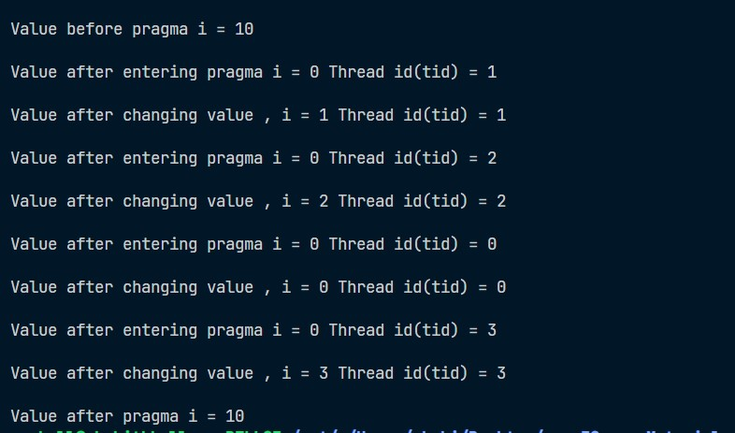

* Declaring i as private makes i private to each thread so that each thread has a copy of i with value 0 and not 10.Each thread then increments the value of i to i + thread_id.

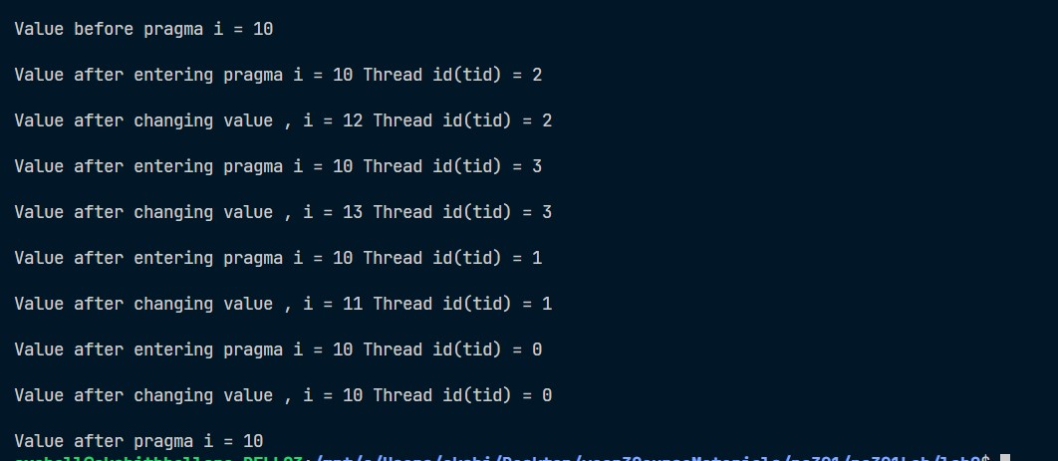

When i is declared to be firstprivate a copy of the variable i is given to each thread with initial value that it had before the parallel region.

In private case local copy of i had the value 0.

In the firstprivate case it had a value of 10.

**3. Program 3**

**Learn the working of lastprivate() clause:**

#include<stdio.h>

#include<omp.h>

void main()

{ int x=0,i,n;

printf("Enter the value of n");

scanf("%d",&n);

#pragma omp parallel

{

int id=omp_get_thread_num();

#pragma omp for lastprivate(i)

for(i=0;i<n;i++)

{

printf("Thread %d: value of i : %d\n",id,i);

x=x+i;

printf("Thread %d: x is %d\n",id,x);

}

}

printf("x is %d\n",x);

printf("i IS %d\n",i);

}

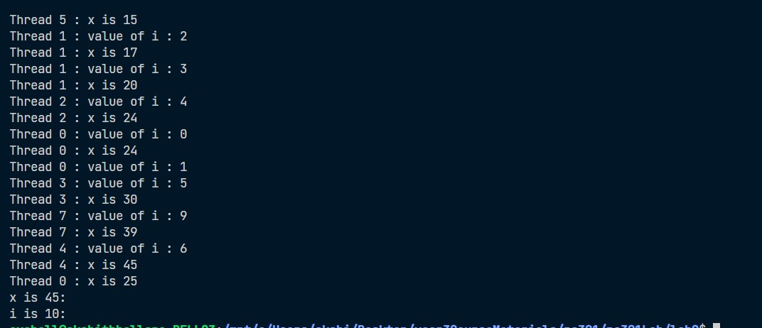

* Lastprivate makes the variable private to each thread but the final value of the variable is set to the private version of whichever thread executes the final iteration.

**4. Demonstration of reduction clause in parallel directive.**

#include<stdio.h>

#include<omp.h>

void main()

{

int x=0;

#pragma omp parallel num_threads(6) reduction(+:x)

{

int id=omp_get_thread_num();

int threads=omp_get_num_threads();

x=x+1;

printf("Hi from %d\n value of x : %d\n",id,x);

}

printf("Final x:%d\n",x);

}

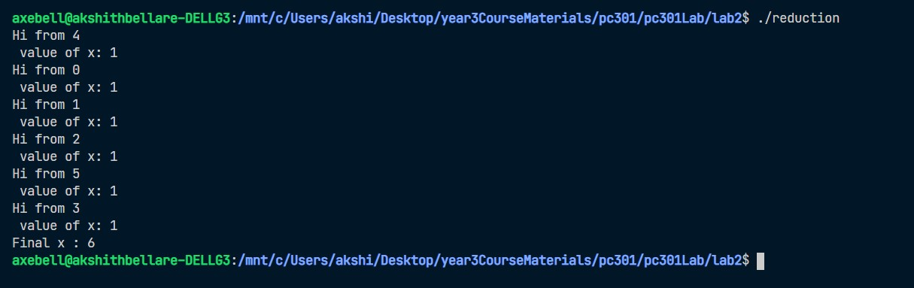

* Reduction clause takes the form of reduction(operator: list of variables that is operated by the operator)

In the example above we are incrementing x. Each thread gets a local copy of x and it performs its operation

Finally all the local copies are combined into a single value using the operator in consideration.

Then this single value is assigned to the global value.

**5. Programming exercise**

1. Write a parallel program to calculate the sum of elements in an array

**Code**

#include<omp.h>

#include<stdio.h>

#define NUM_THREADS 4

int main() {

    int a[] = {1,4,1,3,4,1,5,6,1,22,3,12,54,67,78};

    int len = sizeof(a)/sizeof(a[0]);

    printf("\nlength: %d\n", len);

    int sum[NUM_THREADS]; //array to store the sum calculated by each thread.

    int s = 0; //holds the sum of sums calculated by each thread

    int i,nthreads;

    omp_set_num_threads(NUM_THREADS);

    double start = omp_get_wtime();

    #pragma omp parallel

    {

        int i,id ,nthrds;

        id = omp_get_thread_num();

        nthrds = omp_get_num_threads();

        printf("\nid: %d nthrds: %d\n", id, nthrds);

        //if master thread set the number of threads. Threads allocated might be lesser than what we set.

        if(id ==0) nthreads = nthrds;

        //calculating sum in a round robin approach

        for(i=id, sum[id]=0; i<len; i+=nthrds) {

            sum[id] += a[i];

        }

        printf("\nsum[%d]: %d\n", id, sum[id]);

    }

    double end = omp_get_wtime();

    printf("\ntotal time taken: %f\n", (end - start));

    for(i=0; i<nthreads; ++i) {

        s += sum[i]; //summing up sums calculated by each thread

    }

    printf("\nSum of the array is: %d\n", s);

}

**Screenshots**

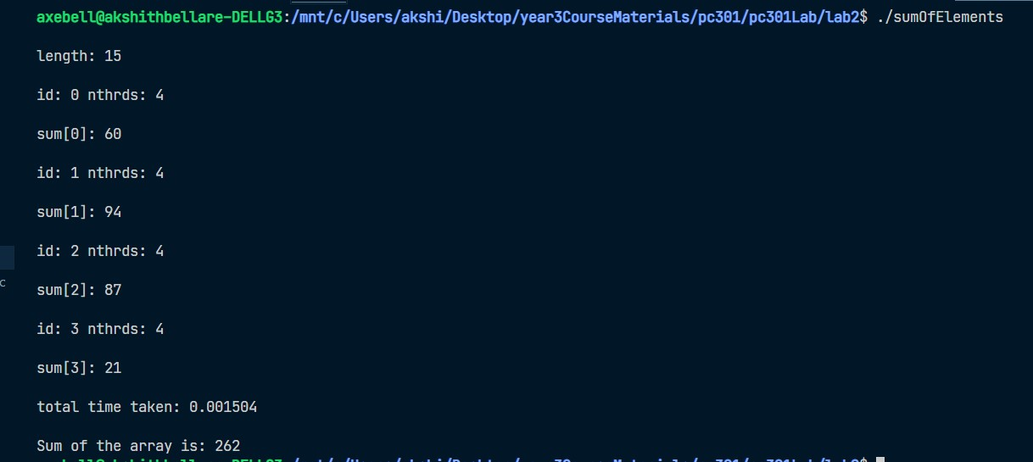

2. Write a parallel program to calculate the a[i]=b[i]+c[i], for all elements in array b[] and c[]

**Code**

#include<stdio.h>

#include<omp.h>

int main() {

    int arr[] =  {1, 2,3,4, 5, 6, 7};

    int barr[] = {2,-1,3,88,12,14,7};

    int len = sizeof(arr)/sizeof(arr[0]);

    int carr[len];

    int i;

    //using the for clause. with schedule decided by the compiler

    #pragma omp parallel

    {

        #pragma omp for

            for(i=0; i<len; ++i) {

                carr[i] = arr[i] + barr[i];

            }

    }

    printf("a[] : ");

    for(int i=0; i<len; ++i) {

        printf("%d ",arr[i]);

    }

    printf("\n");

    printf("b[] : ");

    for(int i=0; i<len; ++i) {

        printf("%d ",barr[i]);

    }

    printf("\n");

    for(i=0; i<len; ++i) {

        printf("a[%d] (%d) + b[%d] (%d)= c[%d] (%d)\n ",i, arr[i], i, barr[i],i , carr[i]);

    }

}

**Screenshots**

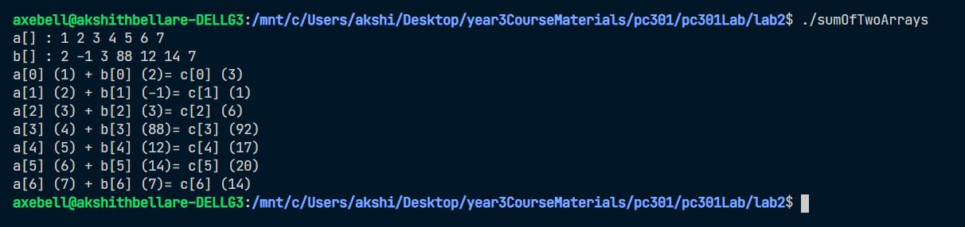

3. Write a parallel program to find the largest among all elements in an array.

**Code**

#include <stdio.h>

#include <omp.h>

#include <limits.h>

int main() {

    int arr[] = {1,2,4,5,11,2,89,12,66,123,2,1234,34,65657,12,3545,12,334,12,-12,23};

    int len = sizeof(arr)/sizeof(arr[0]);

    int max_value = INT_MIN; //set to INT_MIN as the maximum value has to be found

    int i;

    //schedule and chunk size taken from OMP_SCHEDULE env variable

    //reduction used with max operator

    #pragma omp parallel for reduction(max: max_value) schedule(runtime)

        for(i=0; i<len; ++i) {

            if(arr[i] > max_value) {

                max_value = arr[i];

            }

        }

    //reduction clause compares the local copies of each thread and assigne the maximum value out of those

    //copies to the global max_value

    printf("Maximum value is: %d\n", max_value);

}

**Screenshots**

